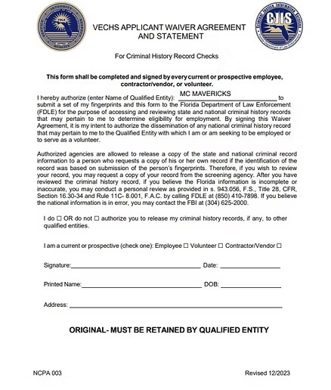

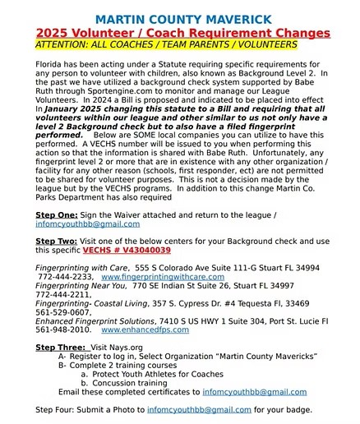

SEND ALL REQUIRED DOCUMENTS AND PHOTO IN ONE EMAIL. IF YOU SEND THEM IN MULTIPLE EMAILS, YOUR EMAILS WILL BE DELETED WITHOUT BEING PROCESSED.

